CS7641-- Randomized Optimization

# Introduction

The purpose of this project is to explore randomized optimization search. This assignment has 3 parts. The first part is about what are these 4 kinds of randomized optimization algorithms; in the second, I will apply these 4 algorithm into a neural network model which was created in assignment 1 using movies review dataset; the last part is discuss the advantages of different optimization algorithms used on different problem.

# Optimization Algorithms

Randomized Optimization algorithms are useful for find global maximum or minimum with continuous and discrete variables. This assignment is mainly about 4 Randomized Optimization algorithms which are Randomized Hill Climbing (RHC), Simulated Annealing (SA), Genetic Algorithm (GA) and MIMIC. All optimization problems result in this assignment were generated as part of the java code that was implemented using ABAGAIL.

## Randomized Hill Climbing

## Randomized Hill Climbing (RHC) search will start at a random state and move to the next state which has higher fitness, it stops moving when reaching the local or global optimum, and restart at random point, the purpose of random restarting is to leave current local optimum. However, randomized optimization algorithm is still weak at moving out of local optimum due to the uncertainty of restarting points.

## Simulated Annealing

Simulated Annealing (SA) models the physical process of heating a material and then slowly lowering the temperature to decrease defects, thus minimizing the system energy.

At each iteration of the simulated annealing algorithm, a new point is randomly generated. It will go to next point with a function of temperature and fitness. Comparing with Randomized Optimization, this algorithm can accept new points which has lower fitness function with lower probability and this avoids being trapped in local minimum. The movement will be more active with high temperature, with temperature gradually decreasing, it will search to converge to a minimum

## Genetic Algorithm

Genetic Algorithm (GA) is a method for solving both constrained and unconstrained optimization problems that is based on natural selection, the process that drives biological evolution. The genetic algorithm repeatedly modifies a population of individual solutions. At each step, the genetic algorithm selects individuals at random from the current population to be parents and uses them to produce the children for the next generation. Over successive generations, the population "evolves" toward an optimal solution.

## MIMIC

Above 3 algorithms are all stating at a random point and move to the ending point depending more their metrics, there is no structure for searching the optimum; also, in most cases, they have an unclear probability distribution. To overcome these issue, MIMIC was created for directly model the probability distribution and successfully define the estimate of that distribution, this will effect the convey structure which is the structure about search of spaces.

# Neural Network with Optimization Algorithms

# Optimization Problems

I found below three optimization problems, which are Continues Peak, Travel Salesman Problem and Flip-Flop to demonstrate different optimizations functions. Below analysis will include problem introduction, Randomized Optimization method selection based on fitness and computational time.

## Continuous Peaks Problem

### 3.1.1 What is the continuous peaks problem

The continuous peaks problem is to figure out the highest peak (global maxima, highlighted in red) versus the subsidiary peaks (local maxima, highlighted in orange). Below is an example for continuous peaks problem.

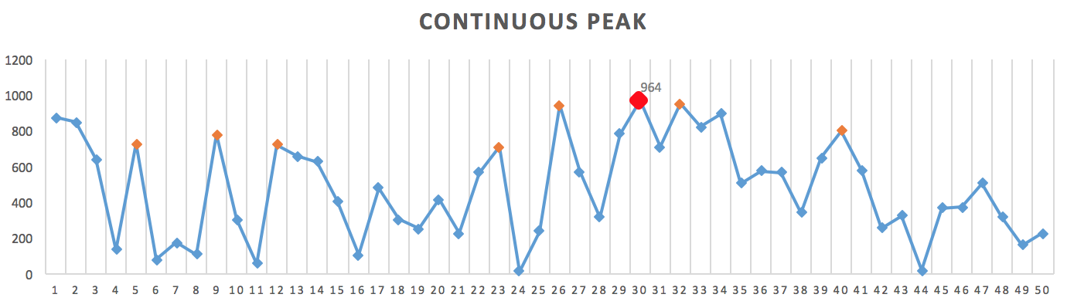

### 3.1.2 Optimization methods comparison

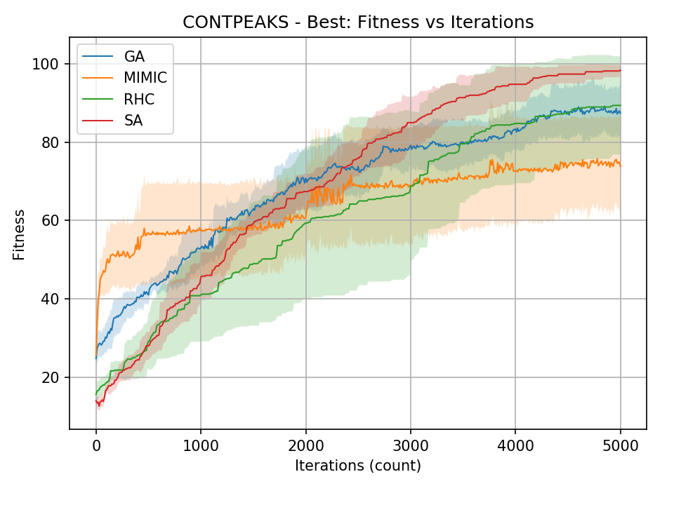Continuous Peak problem has demonstrated the advantage of Simulated Annealing algorithm. From the left line chart, we can see the begin of iterations (no. of iterations < 1000) shows that, MIMIC is a quick leaner which can obtain higher fitness in shorter time. While with the number of iteration increasing, MIMIC weakens. With 5000 iterations, the performance of SA is significantly better than other methods, RHC and GA are almost the same. This continuous peaks problem has showed strengths of SA; it’s performance is robustly increasing with decreasing margin.

Let’s dive deep into SA. The first chart below shows fitness versus no. of iteration using different cooling exponent parameters, all lines are converged at the end except for cooling exponent equals to 0.15. the slope of low cooling exponent is lower than low cooling exponent one, which show with higher cooling exponent, SA can obtain the optimal point with a higher pace, and it totally lost within extremely low no. of iterations (no. of iterations < 500).

In the perspective view of time, we can see from second chart that, the one with lowest cool exponent took the longest time (blue line), while the one with highest cool exponent took the shortest time (purple line), rest of them are close to each other.

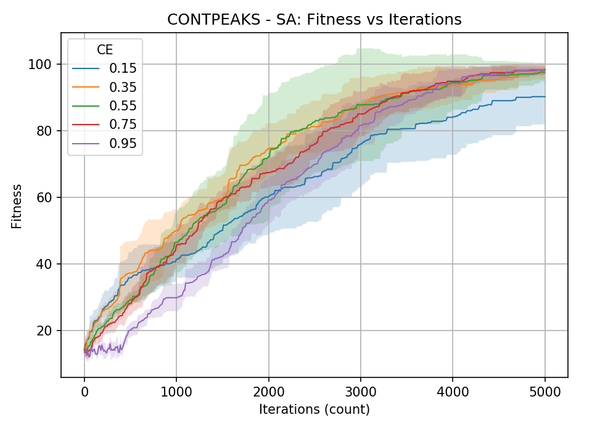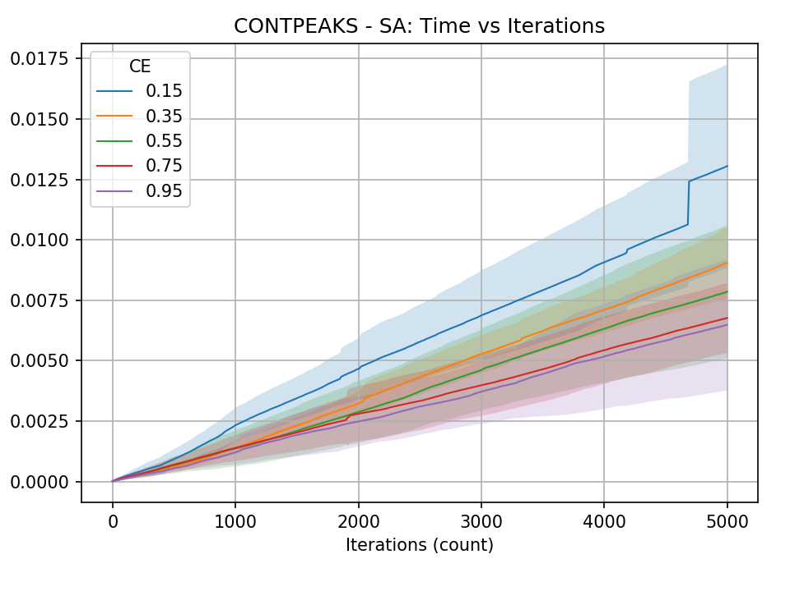

As a conclusion, SA with 0.95 as cooling exponent is the best configuration, in other words, continuous peak problem has highlighted the advantage of Simulated Annealing.

## Flip-Flop

### What is Flip-Flop problem

Flip-Flop is a function which returns the maximum number of flips to make binary string alternate. For example, output of string “001” will be the maximum number of flips which is 2, we can flip 2nd and 3rd bits and let it become “010”. The optimal solution produces a constantly alternating binary string with a return value equal to the length of the string. The function is also known to have a large number of local maximums.

### Optimization methods comparison

Flip-Flop problem has highlighted the advantage of MIMIC randomized optimization. Below is chart shows fitness versus the number of iterations, the performance of MIMIC is significantly better than other functions. First, MIMIC function can find the optimum within the lower number iterations (no. iterations < 1000); second, it obtains the highest fitness along with different no. of iterations. MIMIC performs the worst along any number of iterations, the fitness object has very tinny increase. The performance of SA and RHC are similar.

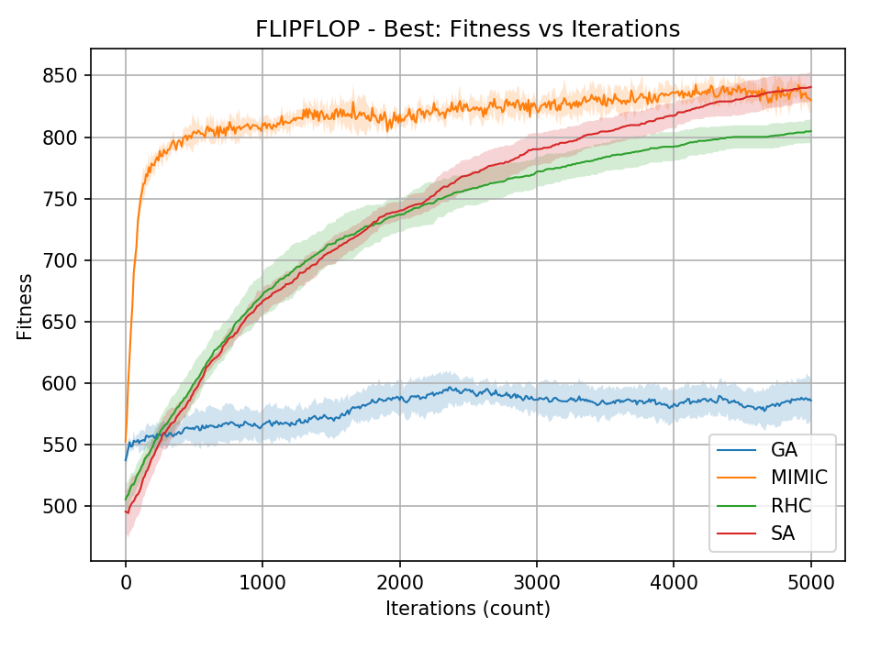

Further tweaking was done below on MIMIC algorithm to see which configuration worked best for the problem at 5000 iterations. Below 2 charts show MIMIC performance with different population sample percentage parameter from 0.1 to 0.9. From the left chart, all experiments with different parameters can converge very quick within 1000 iterations, MIMIC method has the ability to obtain optimum with the least expense. As the perspective of time, the experiment with parameter as 0.9 takes a little longer, the length of time has positive relationship with the fitness they generated, however, the fitness improving is more significant than time consuming volume.

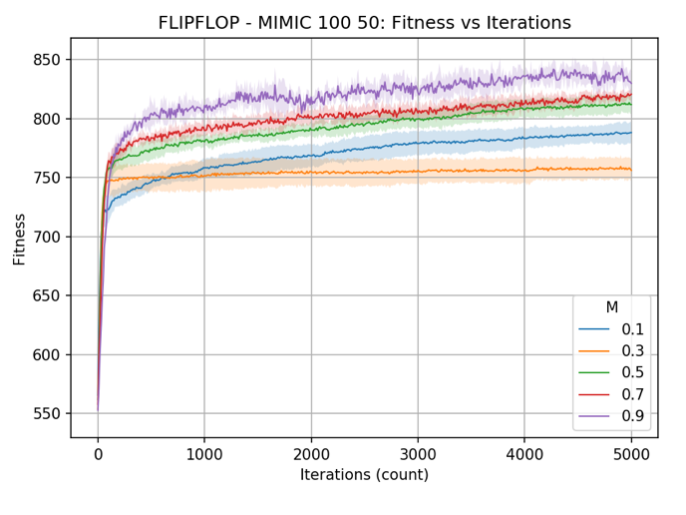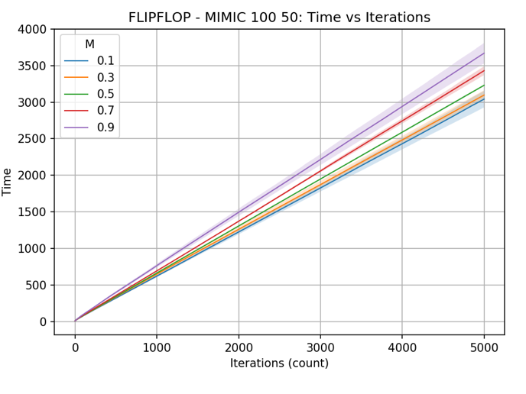

## Travel Salesman Problem

### What is travel salesman problem

Travel salesman problem is a simple optimization case, which is given a set of cities and distance between every pair of cities, the problem is to find the shortest possible route that visits every city exactly once and returns to the starting point. The problem is a famous NP hard problem.

To illustrate the problem, the fitness object of this problem is using reciprocal of distance (d), i.e. 1/d. The randomized optimization algorithm will search for maximum of number of 1/d, which indicated the minimum travel distance.

### Optimization methods comparison

This problem was chosen to highlight abilities of Genetic Algorithm. With 5000 iterations, the fitness object has been plotted below. Genetic Algorithm has performed significantly better than any other algorithms. It obtained the optimum effectively (highest fitness) as well as efficiently (least no. of iterations).

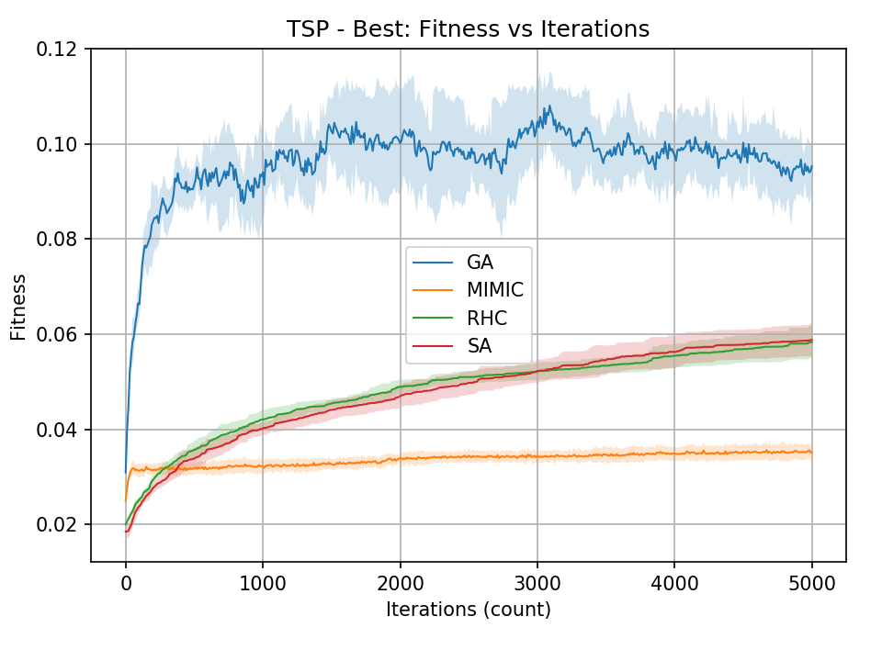

Further investigation pertaining to the performance of the genetic algorithm was done by changing mutate value (holding everything else constant), which is the percentage of mutation portion which introduces random modifications. Below plot shows clear that the best configuration is mutate value as 10, this performed the highest fitness as well as the shortest time.

